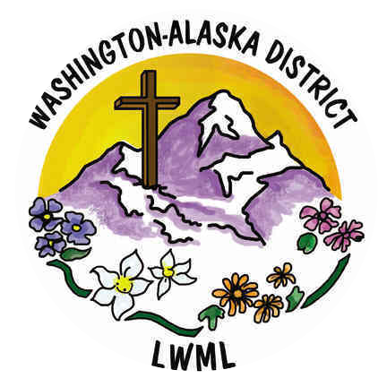

**Short-Term Mission Opportunities**

**March 2025**

1. **Alaska Mission for Christ**

**alaskamissionforchrist.org**

**Alaska Mission for Christ is a Lutheran non-profit organization dedicated to bringing the Gospel of Jesus Christ to Alaska. Short-term volunteers typically commit to 5-10 days working with youth programs, building projects, community outreach, and other activities as needed.**

**For more information contact Katie Siudak:**

[**katie@alaskamissionforchrist.org**](mailto:katie@alaskamissionforchrist.org)

1. **LAMP: Lutheran Association of Missionaries and Pilots**

**lampministry.org**

**LAMP is a cross-cultural ministry sharing Jesus Christ with God’s people in remote areas of Canada. Volunteer teams minister through Vacation Bible School, adult or youth Bible studies, sports programs, or community dinners. Teams are asked to make a commitment to serve 5 years in the same community.**

**For more information email or call:**

[**shelly@lampministry.org**](mailto:shelly@lampministry.org) **1-800-307-4036 Ext. 1**

1. **MOST: Mission Opportunities Short Term**

**mostministries.org**

**Short term mission teams serve in rural and urban settings across the globe. Teams minister to the physical and spiritual needs of people. Projects include: agricultural education, clean water outreach, construction, dental clinics, English camp, eyeglass clinics, health education, plus more.**

**For more information contact:**

**Volunteer Coordinator Kelly Bone at 734-929-1164**

**2**

1. **LCMS Disaster Relief**

**lcms.org/disaster response**

**Mission: LCMS Disaster response ministry responds to immediate and long-term needs following natural and man-made disasters. LERT (Lutheran Early Response Teams) volunteers receive training before joining a response event.**

**For more information visit the website listed above.**

1. **Habitat for Humanity**

**habitat.org**

**Mission: Seeking to put God’s love into action by bringing people together to build homes, communities, and hope. Volunteer opportunities are available in your local areas, nationwide, and around the world.**

**For more information, you can contact Habitat through their website (listed above), or through your local Thrivent representative.**

1. **Mercy Medical Teams**

**servenow.lcms.org/short-term**

**Health care professionals provide desperately needed health care to thousands of patients in underserved regions around the globe. Volunteers (medical professionals) volunteer abroad in a variety of clinical and health related settings. Training is provided.**

**For more information contact Erin Alter, director of short term missions** [**mercyteams@lcms.org**](mailto:mercyteams@lcms.org)

1. **Lutherans in Medical Missions**

**limm.org**

**Medical professionals bring the Good News of Jesus Christ to people all over the world with their special gift of healing. They work in medically underserved communities.**

**For more information contact via email:** [**limm@limm.org**](mailto:limm@limm.org)

**This group also has a Facebook page under the same name.**

**3**

1. **Lutheran Latino Ministries**

**lutheranlatinoministries.org**

**Mission: Provide the Gospel of Christ and engage in ministry with and among Hispanic/Latino people. Reach the lost and disciple the saved by connecting people and resources for gospel outreach; training leaders, and providing culturally and linguistically accessible Word and Sacrament ministry in every corner of the Northwest District.**

**This organization is based in Oregon, but also has some outreach in Washington. Volunteers might help in several ways, such as providing transportation to Sunday School or appointments, helping with English classes, or working with food banks.**

**For more information visit the website (listed above), or call the office at: 503-930-0386**

1. **Fuller Center Disaster ReBuilders**

**disaster-rebuilders.org**

**This Christian organization is dedicated to serving the uninsured and low-income homeowners by rebuilding homes following major disasters. Volunteers work during all seasons, Monday-Friday, and are welcome to join the team for any length of time during any month. Tools are provided and team leaders supervise and teach unskilled groups. Volunteers pay a small fee depending on length of stay.**

**For more information contact:**

**Lyn Wilson, volunteer scheduler 346-763-7499**

**Email:** [**disaster-rebuilders@fullercenter.org**](mailto:disaster-rebuilders@fullercenter.org)

1. **LCMS Office of International Missions**

**There are many options to serve internationally. In 2025, a spring break trip is planned to Central Europe joining missionaries there; Children’s Ministry, parsonage remodel (plus more)in Panama; and English Bible Camp in the Czech Republic.**

**Please visit servenow.lcms.org to see all open opportunities.**

**4**

**11. Grace Giving International**

**This organization offers short term mission trips to Uganda for education, medical, or general for all ages. Their mission is to share Jesus, change lives, and provide opportunities.**

**In 2025, a trip is planned leaving July 4, and returning July 20, working together with Fountain of Hope Ministries. Contact information for this trip is: john@gracegivinginternational .org**

**For more information on Grace Giving International, please visit:**

[**www.gracegivinginternational.org**](http://www.gracegivinginternational.org)

**12. Mission to the Navajos: Shepherd of the Valley Lutheran Church**

**Navajo, New Mexico**

**This mission could include VBS activities for children and families, women’s groups, teen activities, visiting elders and others in remote locations, gardening, painting, and other maintenance.**

**For more information contact Rev. Tim Norton at 1-505-567-4316,**

[**sotvnavpastor@gmail.com**](mailto:sotvnavpastor@gmail.com) **and Facebook: Members and Friends of Shepherd of the Valley LCMS, Navajo, NM**