**Strip Church Ministries** Seattle, Washington

$ 3,000

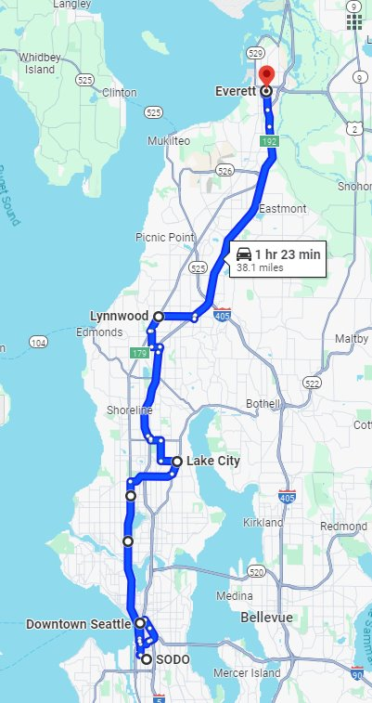****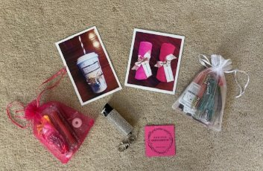

Strip Church Ministries at Lamb of God Lutheran Church in Seattle developed out of asking the question, “Who is my neighbor?” The answer included many in Seattle who are trapped within the sex industry. Strip Church reaches out to the women working the streets as prostitutes, at strip clubs as dancers, and baristas at bikini barista stands with the life-saving, soul healing Gospel of Jesus Christ through building relationships, providing safety kits, and holding prayer groups. Baked cookies and treats are taken by mission members from the church as gifts, letting the women know they are not forgotten. Our district mission grant is dedicated to the growth of this ministry among the women of the sex industry through prayer, proclamation, and service.

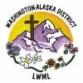

2024-2026 Biennium – LWML Washington-Alaska District