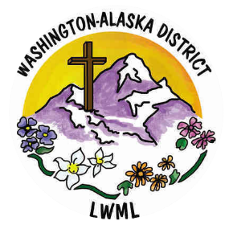

**Upcoming Mission Grants**

***Where are our Mites going Next!***

* **Expanding Gospel Proclamation Worldwide**, a ministry to give financial assistance to international students attending Concordia Seminary (St. Louis) from developing nations. Many of these students would be unable to attend advanced-level theological degree programs at Concordia Seminary without the support of Lutheran bodies such as ours, yet are devoutly passionate, excellent students who seek to spread the Gospel message throughout the world. These international students will be future Lutheran pastors, bringing God’s Word to the people of many continents. See wa-aklwml.org to print a poster for this mission grant!

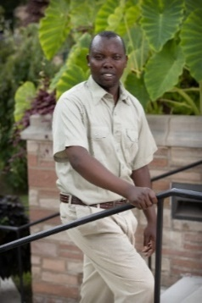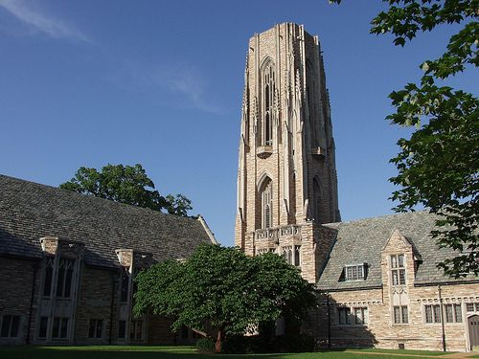

* **Orphan Grain Train – Mercy Meals**, a ministry to provide low-cost, highly nutritious food for the hungry, while sharing Christian love and the Gospel with those who may not know Jesus. Mercy Meals uses volunteers to package nourishing food to be delivered through Orphan Grain Train volunteer resources; this food has touched lives in America and around the World, in orphanages, refugee camps, feeding centers, disaster relief centers, and local food pantries. The Orphan Grain Train volunteer network shares personal and material resources as a loving response to Christ’s love – in this partnership with Mercy Meals, the needs of both physical and spiritual hunger are met in Jesus’ name. Share a Mission Grant Poster for this mission with your LWML group!

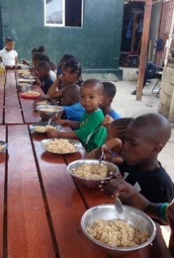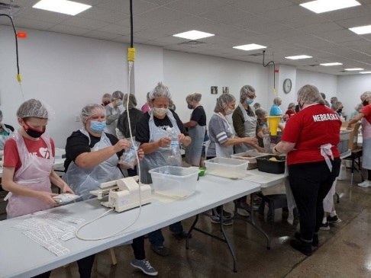



***Continue to keep all our Mission Grant ministries in your prayers***, even after these grants have been paid! A prayer list of our district’s mission grants is available on wa-aklwml.org!

Yours in Christ, Solveig Schick – VP of Gospel Outreach

January 2025