**Concordia International Radio**

Saving Lives Spiritually and Physically

Jacmel, Haiti

$2,000

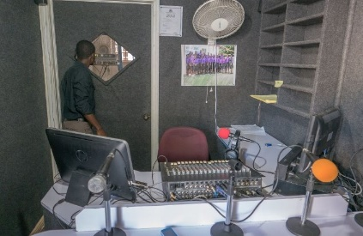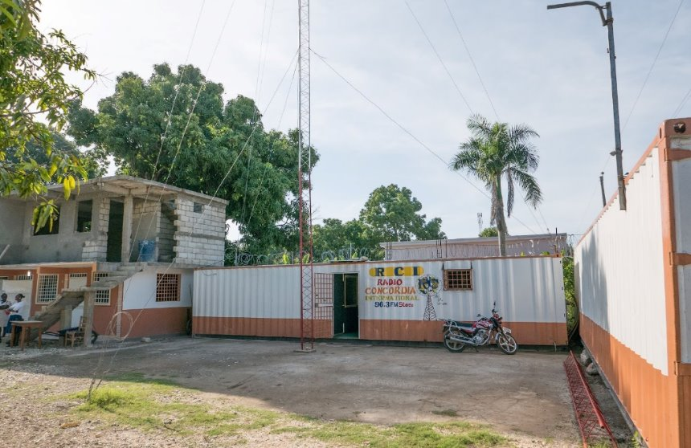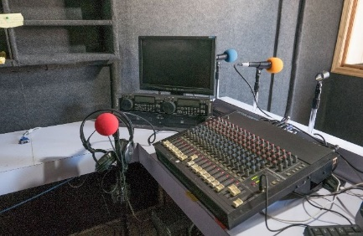

Our grant will assist Ministry in Mission in subsidizing the operation of Concordia International Radio in Jacmel, Haiti, a station that helps deliver the Good News Gospel to the hurting people of Haiti during a time of great upheaval. Ministry in Mission is a Recognized Service Organization of the LCMS with 15 years of experience in Haiti. Extreme weather conditions caused Concordia International Radio’s older equipment to age more quickly. To ensure a continuous, quality radio broadcast, funds are needed to assist in the purchase of three laptops, three multidirectional microphones, a 16-channel mixer, three hard drives, three fans, two tape recorders, six solar panels, and a power inverter. These radio equipment upgrades will enable the continued broadcast of Concordia International Radio to the people of Haiti.

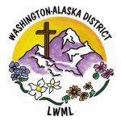

2024-2026 Biennium – LWML Washington-Alaska District