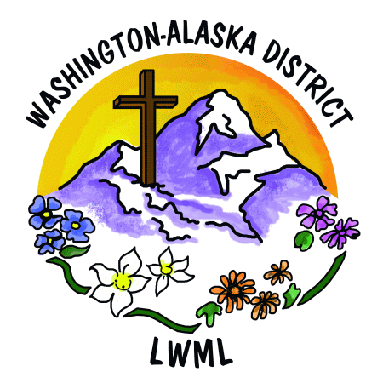**Gospel Outreach**

**Solveig Schick, VP of Gospel Outreach**

At the district convention in June, LWML women from across our Washington-Alaska District shared their hearts and faith in Jesus, joyfully reaffirming their commitment to service and missions in His name! Praise the Lord!

**Mission Grants:**

* The convention approved an **$80,000 goal for 16 new missions** that serve the Lord within our district, our nation, and the world. A prayer list for these mission grants is included in this newsletter. Please consider keeping this list handy for your ongoing prayers! God is mighty and through our prayers and our mites we can spread the love of Christ throughout the world!
* The **Friday mite walk raised $2,015** and the **Friday opening worship mite offering raised $2,508** for these new 2024-2026 missions!
* These convention mites, together with mite offerings from across our district since April, meant we were able to send **mission grant funds of $7,000** to help pay for our first Mission Grant: the **Pastor Parsonage at Funny River, Alaska**. The check was received in Soldotna, Alaska in time for the latter-part of the 2024 building season. We continue to pray as volunteers give of their time and talents to build housing so that a resident pastor can be called to serve at Funny River Community Lutheran Church.
* Mites currently sent to district are earmarked for the Second Harvest Mobile Food Truck ministry in Republic, Washington. This mission grant will enable Trinity Lutheran Church in Republic to provide three or four food trucks to feed hungry families in Ferry County, helping many in vital need of food assistance.
* The LWML WA-AK district convention voted Mirror Ministries of the Tri-Cities, Washington as our **Sunday Morning Offering** recipient. This organization was also the Gifts of the Heart recipient at the 2023 district retreat in Kennewick. A check was sent from the district to **Mirror Ministries in the amount of $1,555.14** and a thank you was received from Executive Director Tricia MacFarlan:

*Thank you so much for supporting the ministry to domestic minor sex trafficking in Tri-Cities and throughout the area, as we bring Christ's love to victims and survivors. Our supporters have brought freedom to over 500 local victims of sex trafficking since 2014 through outreach like that going on today--reaching out to hotels, motels, and attendees at the hydroplane races to be on the lookout for missing teens and women. We have had great success at reducing trafficking instances at these large events, and numerous missing children have been reunited with family through similar and previous efforts!*

* Downloadable 2024-2026 mission grant prayer list, 2024-2026 mission grant descriptions, and 2026-2028 mission grant proposal forms can be found on wa-aklwml.org



**LWML Washington-Alaska District**

**2024-2026 Mission Grants**

**Prayer List**

|  |  |  |
| --- | --- | --- |
|  | **Pray for Missions in Washington, Alaska, America, and the World:** | **Grant** |
| 1 | Aid to Washington-Alaska District Scholarship Fund | $16,000 |
| 2 | Pastor Parsonage – Soldotna, AK | $7,000 |
| 3 | Second Harvest Mobile Food Truck – Republic, WA | $6,000 |
| 4 | Aid to Washington-Alaska District Women for Short Term Missions | $5,000 |
| 5 | Bring Hope, Help & Healing to Pastors, Ministry Workers & Spouses – Shepherd’s Canyon Retreat, Arizona | $3,000 |
| 6 | Seeing Christ Through Dots of Love – Lutheran Braille Workers | $5,000 |
| 7 | Concordia Theological Seminary Food and Clothing Co-op – Food for Seminary Students in Fort Wayne, Indiana | $1,000 |
| 7 | Expanding Gospel Proclamation Worldwide – Concordia Seminary in St. Louis, Missouri | $1,000 |
| 7 | Orphan Grain Train – Mercy Meals | $10,000 |
| 10 | 55 X 55 Initiative LAMP Ministry in British Columbia, Canada | $1,000 |
| 10 | Strip Church Ministries – Seattle, Washington | $3,000 |
| 12 | Lutheran Ministry Services Northwest – Adopt a Care Center | $3,500 |
| 13 | Feeding Haitian Children for the Kingdom – Trinity HOPE | $10,000 |
| 14 | Concordia International Radio Saves Lives Spiritually and Physically – Jacmel, Haiti | $2,000 |
| 15 | Orphan Grain Train – Reaching Out to Ukrainians | $5,000 |
| 16 | Walking Together in the Mission Field – Alliance Missionaries – LCMS | $1,500 |
|  | Mite Goal 2024-2026 | $80,000 |

*WA-AK Missions Adopted June 22, 2024*

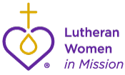**Mission Servants**

We were blessed at district convention by **Galina Volchkova**, who spoke movingly about the needs of **Ukrainian refugees served by the Gibson Center in Everett**, our **Gifts from the Heart** recipient. Thanks to all of you at the convention and at home who contributed to this important mission. Many thanks to Joanne Hopper for her faithful service as Chair of the Mission Servants Committee, as she steps down from this position and serves the Lord in other ways!

Galina Volchkova wrote Ruth Ann Shimoi, VP of Gospel Outreach 2020-2024:

*Ruth Ann, I want to express my deepest appreciation for the Lutheran Women’s Missionary League, for your kind hearts and generosity! Your gifts mean the world for those refugees who are trying to recover from trauma and handle the chaos of their first steps in the US. I am touched by your mission, and your effort to help people in need. Ukrainian refugee families are resilient and have many strengths, but they are very vulnerable at the beginning of their new journey here. Your support will brighten many lives! Many blessings to you and LWML* Y

**Short Term Missions**

You may have seen the wonderful convention display of short term missions undertaken by LCMS women throughout the 2024-2026 biennium. Many thanks to Patrice Cornelius for her faithful service as Chairman of the Short Term Missions Committee! She will be stepping down from this position, but will continue on the committee, ready to assist the next Short Term Missions chairman. The following are excerpts from the mission report written by Jahna Polluck describing their **June 2024 Nunapitchuck Mission**:

*The Nunapitchuk Mission, supported by LWML WA-AK District Short Term Missions, shares the Gospel of Jesus Christ through a summer VBS program with village partners who invite us each year and support this annual tradition as a component of ongoing ministry. God sent a team of six missionaries by small plane and boat to a Yup’ik village on the Yukon-Kuskokwim River Delta in SW Alaska this June to share the love of Jesus. VBS curriculum and supplies were purchased with the support of a LWML grant. Our VBS theme was “God’s Incredible Gifts” ~ or “Cikiiutet Irrinarqelriit Agayutmek” in Yup’ik. Our lessons each day incorporated Bible stories, music, crafts and games to reveal God’s Incredible Creation, Forgiveness, Restoration, Redemption, and Love. In all of this, we remember that we are called to be the hands and feet of Jesus in this place, and are grateful to witness the powerful presence of the Holy Spirit as faith is nurtured. We give thanks to God for all His gifts, and we give thanks for the generosity of the WA-AK LWML. The grant was a tremendous blessing! Your love has reached the boardwalks of Nunapitchuk, Alaska, where nearly 100 children have the Word of God in their hands and on their lips, through pictures, print, and song provided by this grant. To God be the glory!*

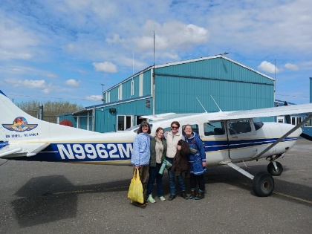 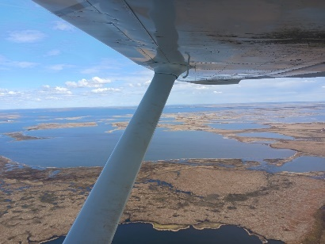 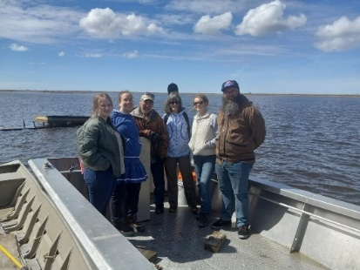

After flying by jet from Anchorage to Bethel, we board a small plane to get to the village. We then travel by boat from the airstrip to the village. There are no roads. This region is very low-lying tundra, so the structures are built on pilings, and you walk on wooden boardwalks.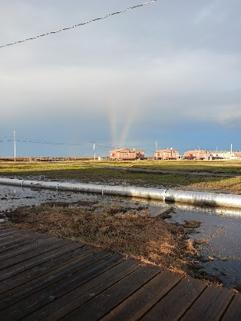 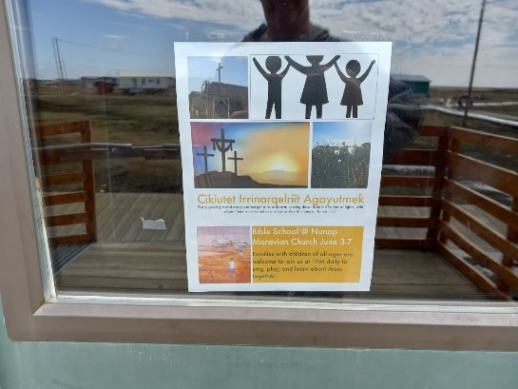 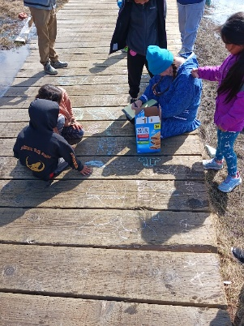 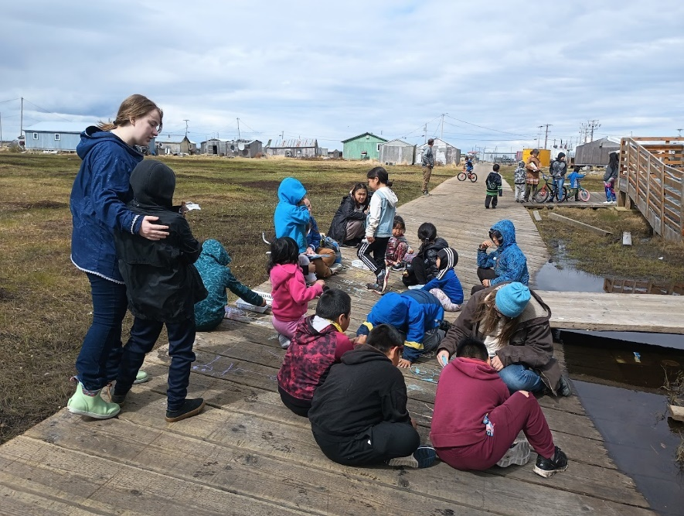

Daily Bible school for all ages ~ babies to elders ~ included outdoor welcome with snack, indoor music, Bible story, craft, and outdoor games with more snack! The kids love to ride their bikes on the boardwalk, so we always have a bike repair clinic and jamboree one evening.

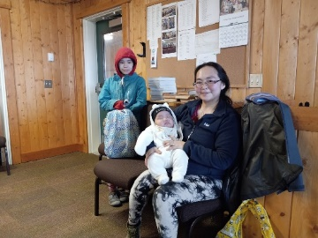 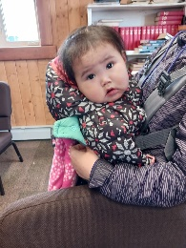 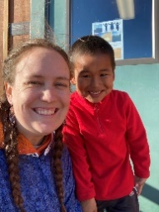 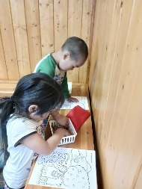 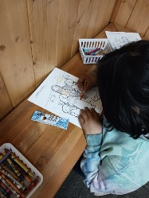 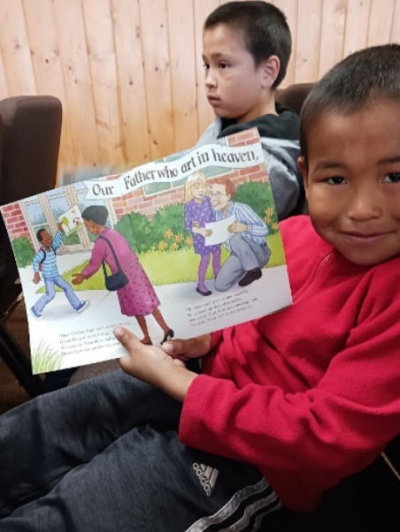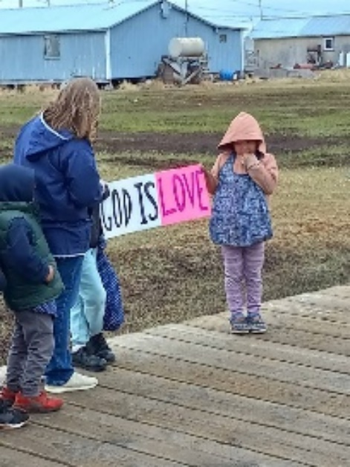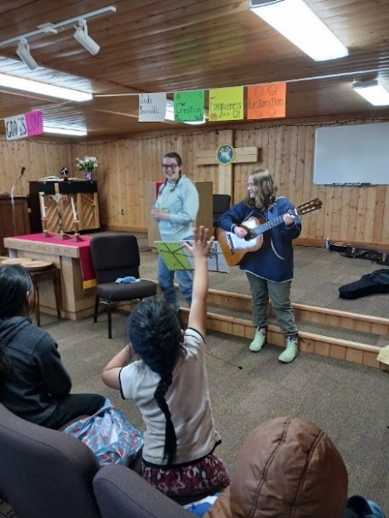 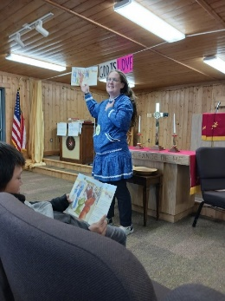 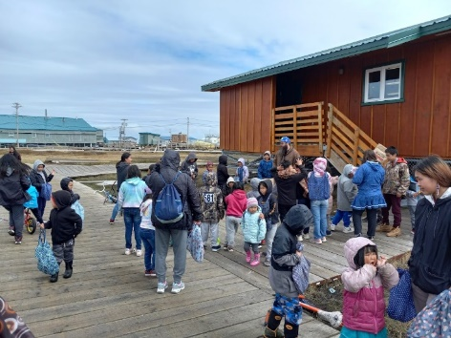 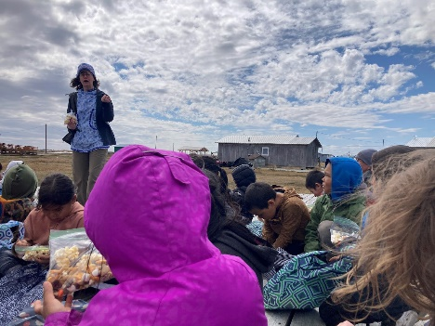

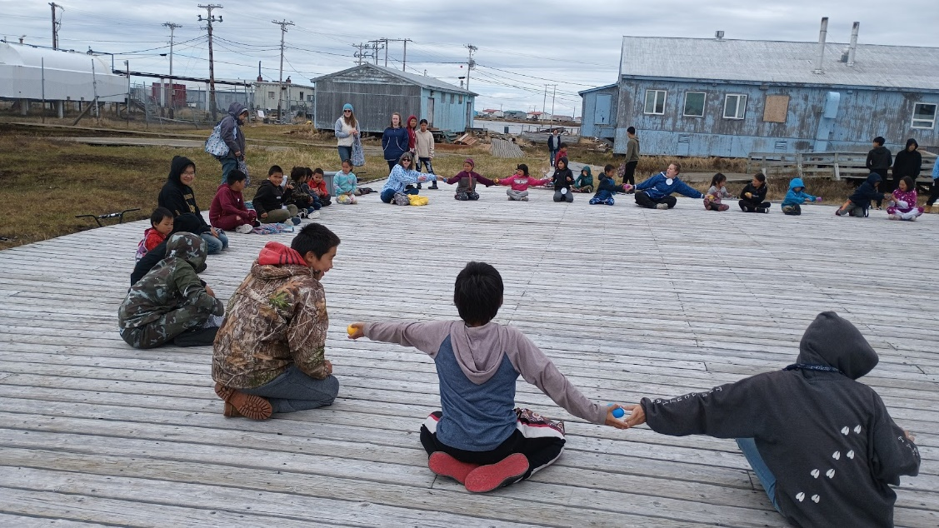 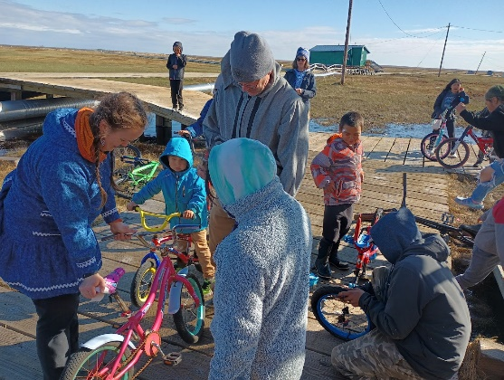 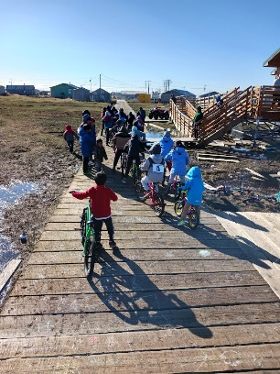 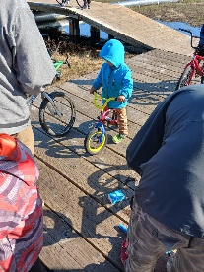 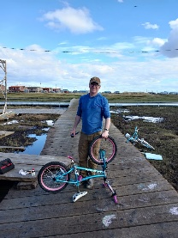 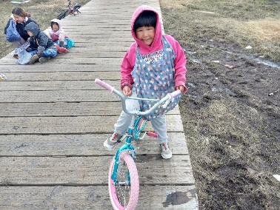 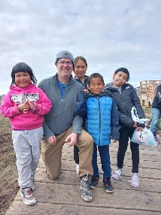 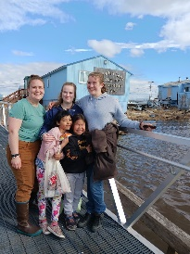 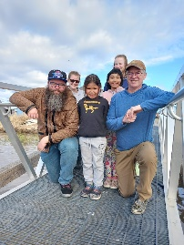 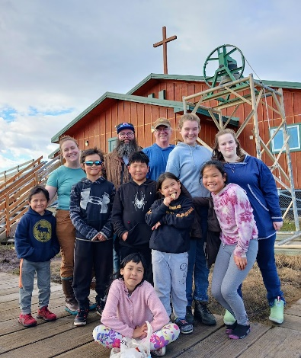

You can see "this little Gospel light of mine" shining all around Nunapitchuk, up and down the boardwalks. Quyana!