Orphan Grain Train

Mercy Meals for Orphan Grain Train

$ 10,000

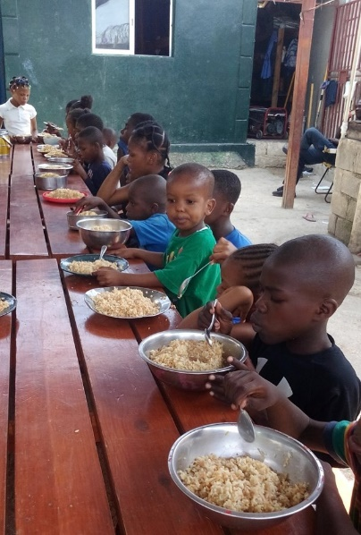

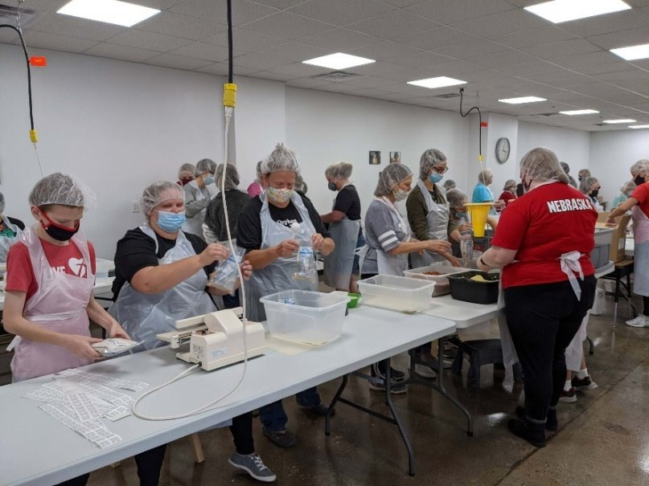

Working through the church, Orphan Grain Train has carried out the Lord’s mission for 31 years by providing humanitarian service to orphans and others experiencing poverty within the United States and internationally. Working closely with Mercy Meals, Orphan Grain Train Mercy Meals will provide low-cost, highly nutritious food for the hungry with the funds from this grant, while sharing Christian love and the Gospel with those who may not know about Jesus.

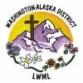

2024-2026 Biennium – LWML Washington-Alaska District