**Second Harvest Mobile Food Truck**

at Trinity Lutheran Church

Republic, Washington

$ 6,000

**********************************************************************************************

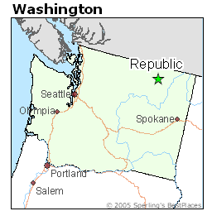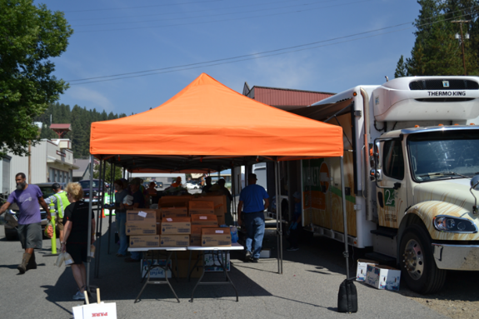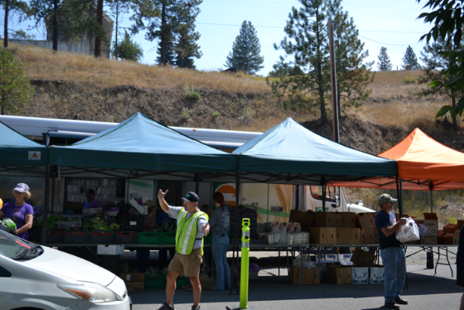

Trinity Lutheran Church of Republic serves the community of Republic and Ferry County with Second Harvest Mobile Food Trucks three times a year. The mobile food trucks cost approximately $2,000 per truck to supply, with each visiting truck designed to feed over 200 families. Providing this service makes a significant difference in the lives of people struggling to purchase food for their families. Approximately 65% of the congregation participates in handing out the food, serving their community with both Christian love and practical nourishment. This LWML district grant will help provide three to four food trucks to feed hungry families in Ferry County.

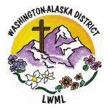

2024-2026 Biennium – LWML Washington-Alaska District