**Lutheran Ministry Services Northwest**

**Adopt a Care Center**

$ 3,500

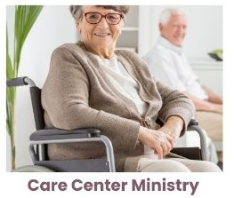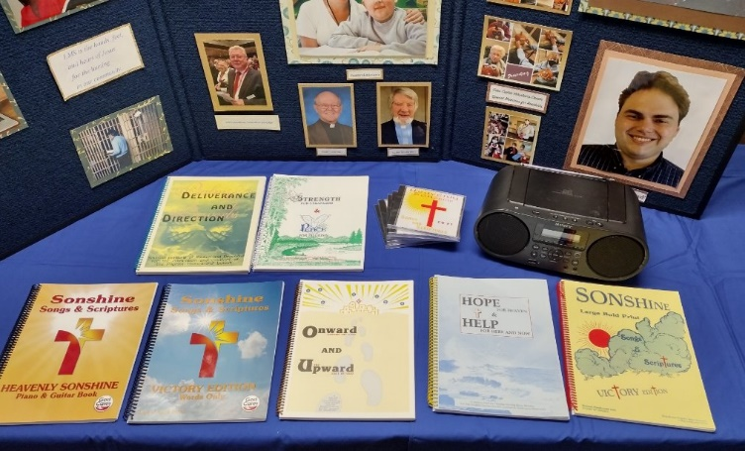



This mission grant will equip 10 additional care center ministry teams with a package of resources for volunteers for use at care centers. A package of resources includes a supply of large-print song books (5), devotion materials geared for older adults (set of 3 books), CDs to accompany songbooks for volunteers who do not play an instrument or feel

confident singing (one set of 4 CDs that accompany songbook), and a CD player capable of being used in a larger room with hearing impaired individuals. Our district mission grant will help equip Lutheran Ministry Services Northwest care center ministry teams; their presence makes a world of difference to care center residents, many of whom otherwise would receive only one or two visits per month.

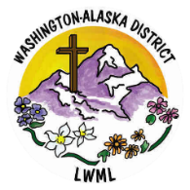

2024-2026 Biennium – LWML Washington-Alaska District