Orphan Grain Train

Reaching out to Ukrainians

$5,000

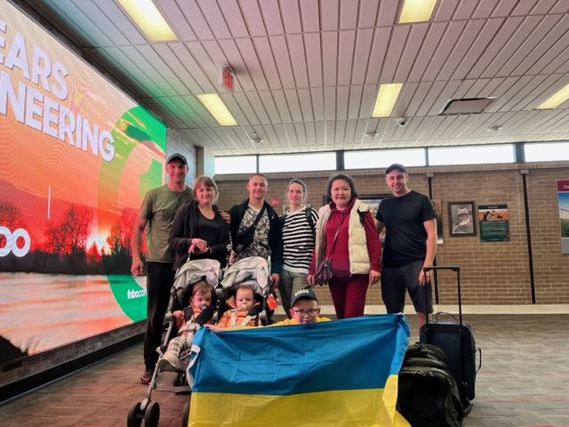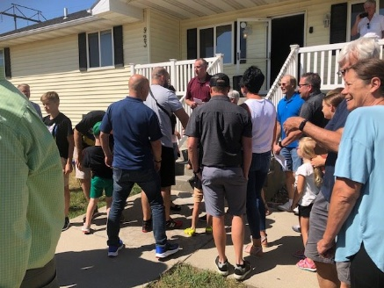

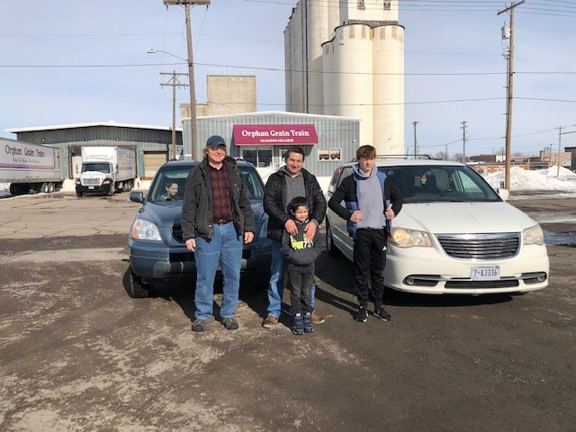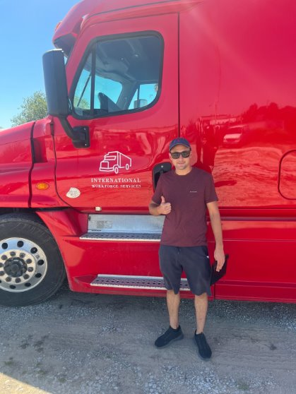

Orphan Grain Train has already relocated and provided assimilation and continued funding for Ukrainians who have fled the devastating war in Ukraine to the United States. With this grant, Orphan Grain Train will provide for the spiritual and material needs of Ukrainians displaced by war to Norfolk, Nebraska, with funding for relocation, assimilation, and ongoing expenses as well as for Gospel Outreach.

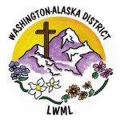

2024-2026 Biennium – LWML Washington-Alaska District