Concordia Seminary, St. Louis

Expanding Gospel Proclamation Worldwide

$1,000

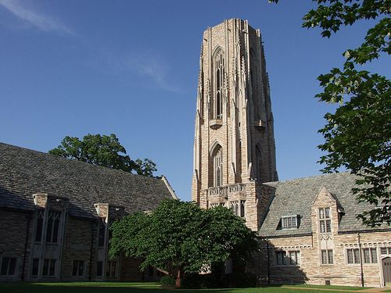

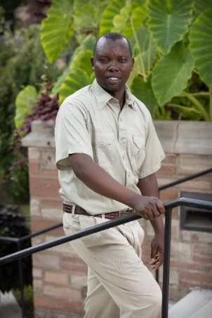

There is a significant shortage of well-formed Lutheran pastors with advanced theological education in most of these countries, options outside the United States are few for the advanced theological study that is needed for these pastors, and few overseas Lutheran church bodies have the resources to send their most capable students to the United States for this advanced study.

Concordia Seminary continues to welcome and form highly qualified international students and the LCMS has named supporting and expanding theological education as one of its key mission priorities to ensure that there will be well-formed pastors to lead Lutheran congregations throughout the world.

The mission grant of $1,000 will be used to offset international students’ education costs to attend Concordia Seminary, St Louis.

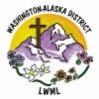

2024-2026 Biennium – LWML Washington-Alaska District