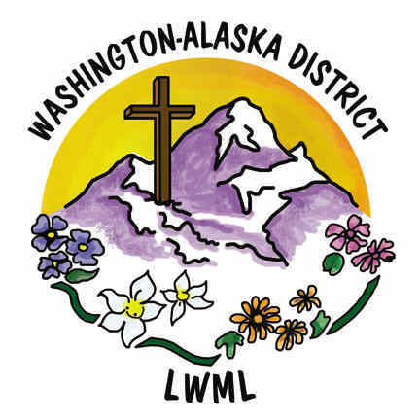
Nominations 2024-26

Having gifts that differ according to the grace given to us, let us use them…. Romans 12:6a (ESV)

It’s time to start searching for those women willing to be on the ballot for our
2026 convention in Spokane, WA

The offices that will be open are:

President

Vice President of Organizational Resources

Vice President of Special Focus Ministries

Financial Secretary

Pastoral Counselor East Side

Nominating Committee (needs 7)

Deadline for nominations:

Send nominations to:
Jayne Bowes
Nominating Committee Chairman
P.O. Box 214
Okanogan, WA 98840
Any questions, please call Jayne at 509-429-1147
Email – jbinspire1@outlook.com

