**Lutheran Braille Workers** Seeing Christ Through Dots of Love

$ 5,000

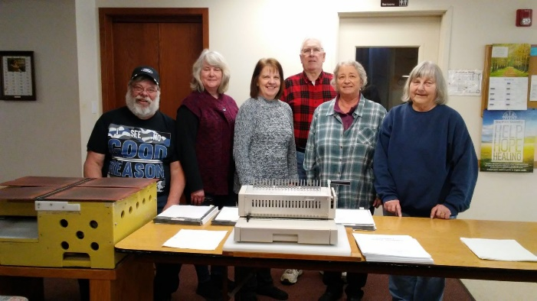

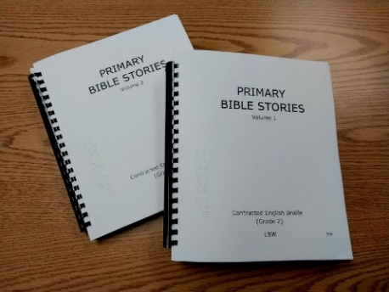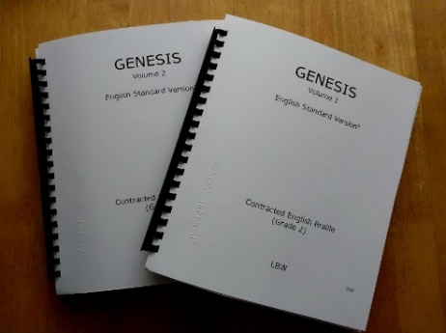

The LBW project “Seeing Christ Through Dots of Love” offers LWML Washington-Alaska District women the opportunity to nurture their faith in Christ through sharing the Word of God with people in Africa who are blind, wishing to live in the Light of Jesus.

The grant amount of $5,000 to Lutheran Braille Workers will help fund the production and distribution of Braille volumes of Bibles and other Christian materials in multiple languages for Africa at the two LBW Ministry Production Centers (MPC) located in Everett and Federal Way, Washington, and explore adding a new MPC, if interest exists.



2024-2026 Biennium – LWML Washington-Alaska District