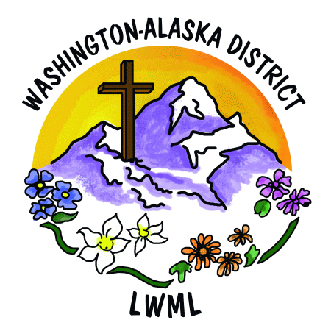

**LWML Washington-Alaska District**

**2024-2026 Mission Grants**

**Prayer List**

|  |  |  |
| --- | --- | --- |
|  | **Pray for Missions in Washington, Alaska, America, and the World:** | **Grant** |
| 1 | Aid to Washington-Alaska District Scholarship Fund | $16,000 |
| 2 | Pastor Parsonage – Soldotna, AK | $7,000 |
| 3 | Second Harvest Mobile Food Truck – Republic, WA | $6,000 |
| 4 | Aid to Washington-Alaska District Women for Short-Term Missions | $5,000 |
| 5 | Bring Hope, Help & Healing to Pastors, Ministry Workers & Spouses – Shepherd’s Canyon Retreat, Arizona | $3,000 |
| 6 | Seeing Christ Through Dots of Love – Lutheran Braille Workers | $5,000 |
| 7 | Concordia Theological Seminary Food and Clothing Co-op – Food for Seminary Students in Fort Wayne, Indiana | $1,000 |
| 7 | Expanding Gospel Proclamation Worldwide – Concordia Seminary in St. Louis, Missouri | $1,000 |
| 7 | Orphan Grain Train – Mercy Meals | $10,000 |
| 10 | 55 X 55 Initiative LAMP Ministry in British Columbia, Canada | $1,000 |
| 10 | Strip Church Ministries – Seattle, Washington | $3,000 |
| 12 | Lutheran Ministry Services Northwest – Adopt a Care Center | $3,500 |
| 13 | Feeding Haitian Children for the Kingdom – Trinity HOPE | $10,000 |
| 14 | Concordia International Radio Saves Lives Spiritually and Physically – Jacmel, Haiti | $2,000 |
| 15 | Orphan Grain Train – Reaching Out to Ukrainians | $5,000 |
| 16 | Walking Together in the Mission Field – Alliance Missionaries – LCMS | $1,500 |
|  | Mite Goal 2024-2026 | $80,000 |

*WA-AK Missions Adopted June 22, 2024*