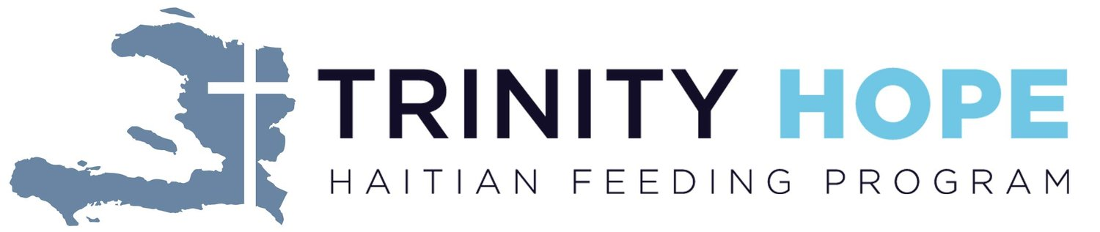 **Trinity HOPE**

Feeding Haitian Children for the Kingdom

$10,000

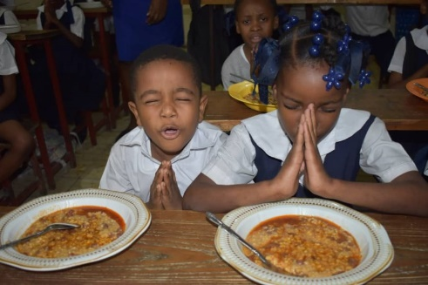

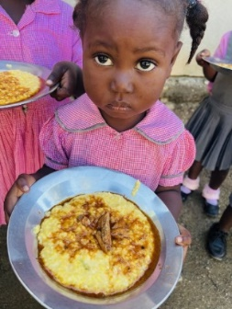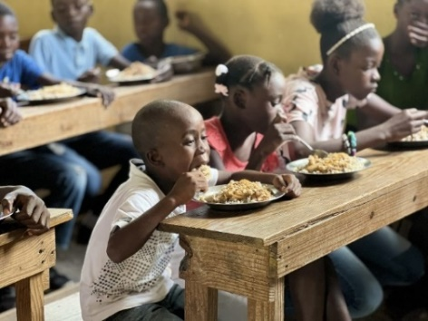

Trinity HOPE purchases food from Haitian vendors to provide a noon meal to children, teachers, and cooks in over 240 Christian schools. The grant money is designated to one specific Haitian-Lutheran school to sponsor the feeding program at that school. The grant covers overall costs for approximately 200 meals per school day for one school year. Providing a noon meal for the hungry children in our Lutheran schools in Haiti is a powerful witness used by the Holy Spirit to discredit the Voodoo teaching that God is unapproachable and non-responsive to Haitians. This ministry can be instrumental in bringing whole families to the knowledge of Christ and demonstrating the love of Jesus through word and deed.



2024-2026 Biennium – LWML Washington-Alaska District