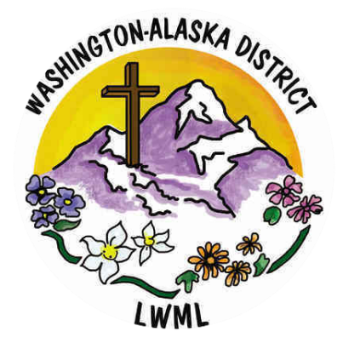

October 2024

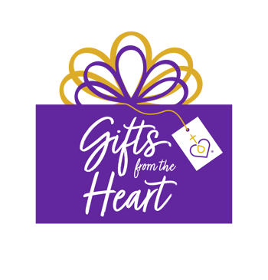Sisters in Christ:

This is Ruth Ann Shimoi, the chair for Gifts from the Heart Committee. This committee under the umbrella of Gospel Outreach, is my passion. I had sent an email to the Zone presidents asking what their zones had gathered at their Rallies. There are so many organizations and the giving is amazing.

Hood Canal: Peninsula Behavioral Health’s Community Outreach Van: gathered anything and everything for the driver of this Van to hand out to those living outside (backpacks, flashlights, tarps, etc.) What an outreach.

Mt. Baker: Whatcom Pregnancy Clinic: All things baby related. From the picture a lot was collected and then given.

Olympic Zone: invited the new Pastor for Trinity Chapel (use to be Chapel on the Ave, University of Washington) and then gifted him with food and monetary donations which he will use for the Wednesday evening meals to which the University students are invited. Please pray for this ministry.

Puget Sound Zone: Snack related items for the Preschool at All Saints.

Rainier Zone: school supplies for the teachers at Concordia Christian Academy across the street from Good Shepherd where the rally was held.

So many places and so much need. Thank you for giving,

If any of your Groups are wanting suggestions, do reach out to me. I am happy to give suggestions.

Blessings,

Ruth Ann Shimoi

LWML WA-AK District

Gifts from the Heart Chair