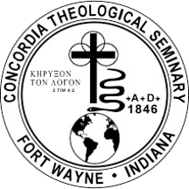**Concordia Theological Seminary**  Food for Seminary Students

in Fort Wayne, Indiana

$1,000

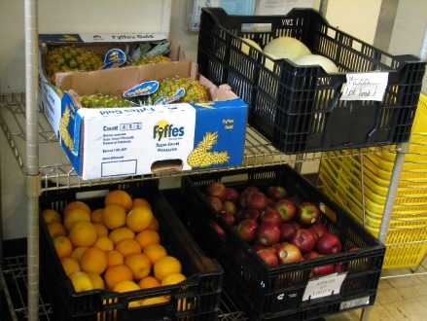

The Food and Clothing Co-op on the campus of Concordia Theological Seminary plays a key role in helping students feed and clothe their families during their seminary years. Nearly 60% of students are married, second career, with families. The Food Co-op is currently able to supply between 80% and 85% of all food and household needs each

month at no cost to the student. Because the Co-op is such a vital part of the seminary students’ lives, it is important that the seminary continue to raise funds to supply food for the Food Co-op. Our district mission grant will fund perishable items for the Food and Clothing Co-op for the use of students and their families who may be experiencing

financial difficulties while attending seminary.

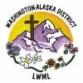

2024-2026 Biennium – LWML Washington-Alaska District