**Pastor Parsonage**

at Funny River Lutheran Church

Soldotna, Alaska

$ 7,000

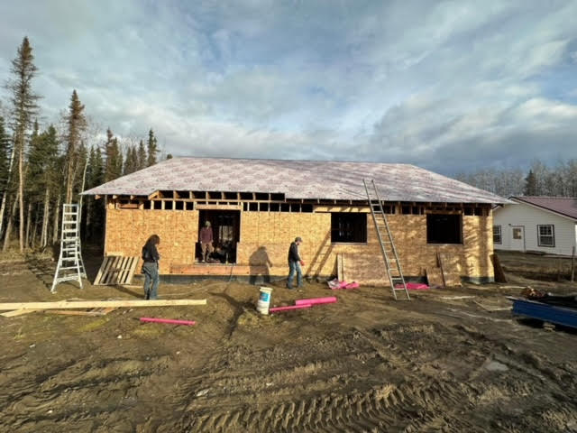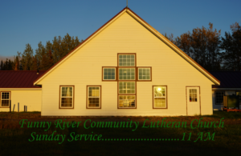

Funny River Lutheran Church

Parsonage under construction

Funny River, Sterling, and Kenai Lutheran congregations currently have an interim pastor. The Funny River Community Lutheran Church congregation cannot afford to hire a pastor for the church without providing a parsonage due to the high cost of housing in the area. Funny River is building the parsonage using volunteer labor with the goal of hiring a resident pastor to live in the parsonage and serve the Funny River congregation full-time, reaching out to the community of 3,000 and growing the church. Our district grant will help with construction materials for the roof and structure.

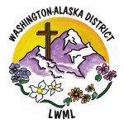

2024-2026 Biennium – LWML Washington-Alaska District