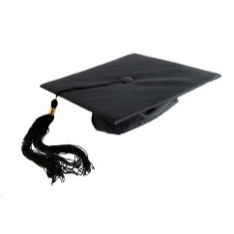**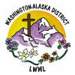 Aid to Washington-Alaska District** **Scholarship Fund**

$16,000

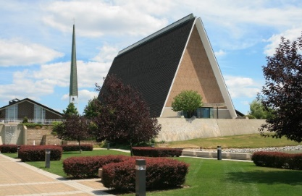

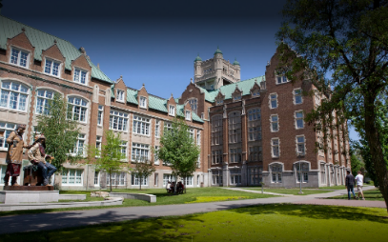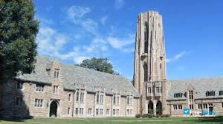

The Lutheran Women’s Missionary League Washington-Alaska District assists scholarship recipients (students studying for full-time church work and enrolled at LCMS seminaries, universities, and colleges) each biennium, with each student receiving a grant ranging from $2,000 to $4,000 over a two-year period. This grant transfers funds to the Scholarship Fund on a regular basis. These funds, along with monies given directly to the Scholarship Fund are awarded by the Scholarship Committee on an annual basis in amounts determined by the Committee under the direction of the Executive Committee





2024-2026 Biennium – LWML Washington-Alaska District