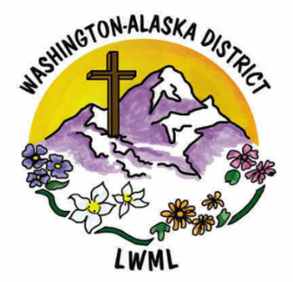

**Aid to Washington-Alaska**

**Short-Term Missions**

$5,000

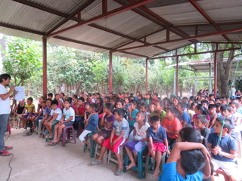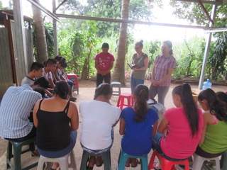

The Washington-Alaska District supports short-term mission opportunities occurring between convention years to help our LCMS women serve the Lord through short-term mission opportunities that are often spontaneous where financial help is needed immediately.

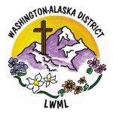

2024-2026 Biennium – LWML Washington-Alaska District