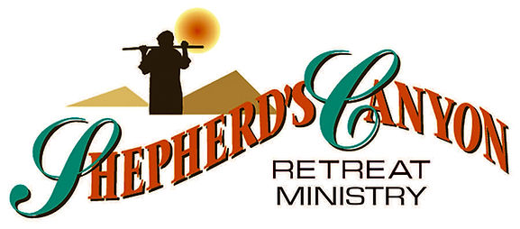

Shepherd’s Canyon Retreat, Arizona

Bringing Hope, Help, and Healing to Pastors, Ministry Workers and Spouses

$ 3,000

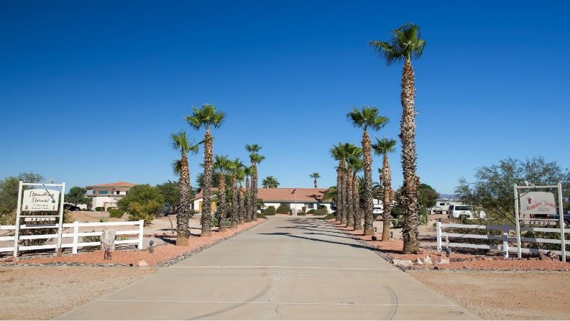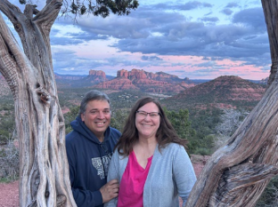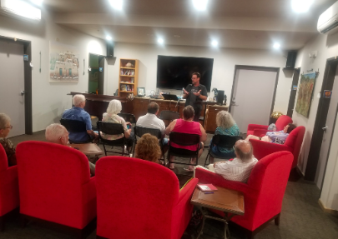

This grant will enable Shepherd’s Canyon Retreat to offer scholarships for pastors, ministry workers, and spouses who need extra financial assistance in order to attend a weeklong counseling retreat for men and women in full-time ministry who are in various stages of burnout, stress, depression, compassion fatigue, and conflicts of all kinds. By God’s grace, Shepherd’s Canyon Retreat, a LCMS Recognized Service Organization, has helped hundreds of ministry workers over the years, many of whom were ready to quit the ministry (or life itself) before their time at this Christian retreat. Our mission grant seeks to bring hope, help, and healing to pastors, ministry workers, and spouses who are called to help people in the ministries and communities where they live.

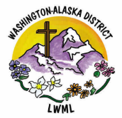

2024-2026 Biennium – LWML Washington-Alaska District