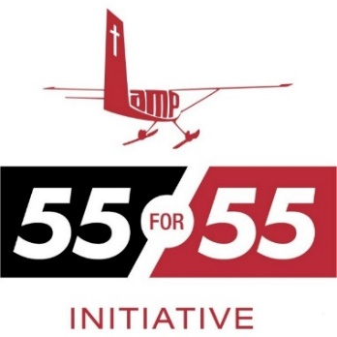

Lamp Ministry in British Columbia, Canada

$ 1,000

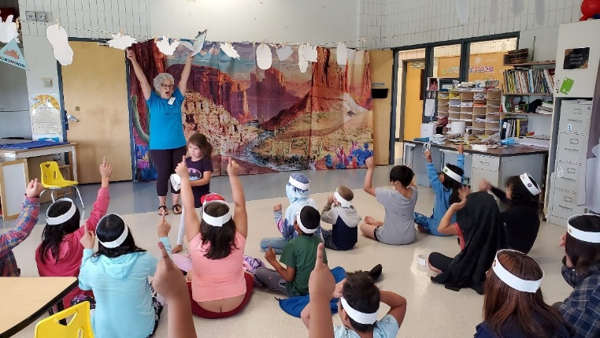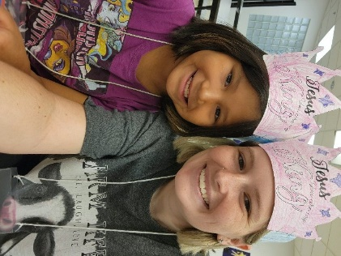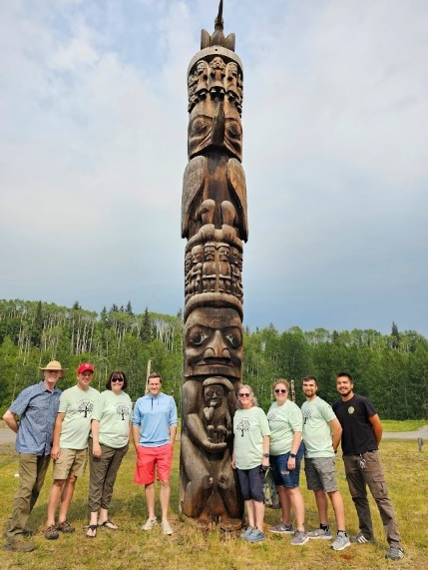

LAMP is a cross-cultural ministry sharing Jesus Christ with God’s people in remote areas of Canada. The 55x55 Initiative is to have 55 mission trips for their 55th Anniversary in 2025. Communities served by LAMP in the past have pleaded with LAMP to continue providing ministry to their children. These children live in isolated and harsh conditions and can feel forgotten by the world; they need to know they have an ever-present friend in Jesus. Under this new initiative, LAMP wishes to go even farther to the ends of the earth to reach new communities. Our district grant will help reach Indigenous people in northern Canada with the Gospel of Jesus Christ.

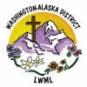

2024-2026 Biennium – LWML Washington-Alaska District