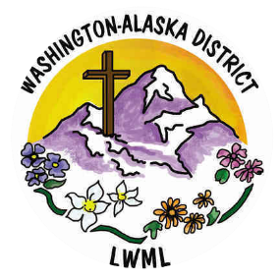**Mission Grant Committee Report – January 2025**

Solveig Schick, Chairman

**Working in His Kingdom!**

Your mites are making a difference in God’s Kingdom! Check out wa-aklwml.org to keep up-to-date on the district missions we have funded! Since the last newsletter, your mites were sent into God’s Vineyard for the following missions:

* 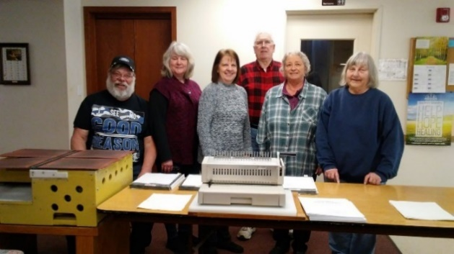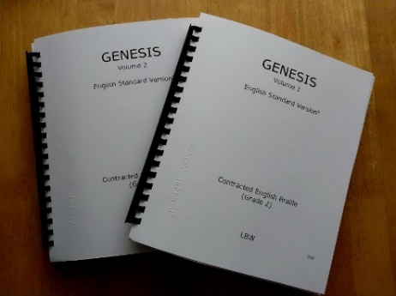**Lutheran Braille Workers’ Seeing Christ Through Dots of Love Ministry** was funded in the amount of $5,000. Through this mission grant, your mites help fund an LBW project to share the Word of God with people in Africa who are blind, through the production and distribution of Braille volumes of Bibles and other Christian materials in multiple languages. These Braille books may be some people’s first experience with the Word of God, a blessing that can enable them to live in the Light of Jesus! ***We pray that God continues to guide the hands of those who create these books and that, through these materials, many who live in darkness may know the love and perfect peace of our Savior!*** See the Mission Grant Poster on wa-aklwml.org!

* 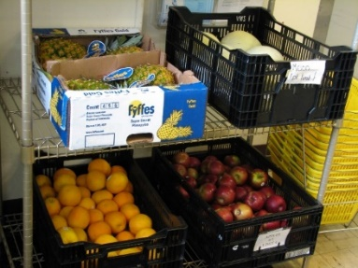**Concordia Theological Seminary (CTSFW) Food for Seminary Students Ministry** was funded in the amount of $1,000. Through your mites and others, the Food Co-op at CTSFW is able to purchase perishable items for the use of seminary students and their families who may be experiencing financial difficulties as they study for the ministry. Nearly 60% of students are married, second career, with families. The Food Co-op is currently able to supply between 80% and 85% of their food needs each month at no cost to the student. ***We pray for those called to the ministry. Ease their worries about the daily needs of their families through this mission grant as they prepare to minister to our congregations and spread the Gospel as God leads!***

Remember to check out lwml.org to see the where your mites are working for Jesus through our LWML national grants! Stories, Devotions, Prayer Guides, and Bulletin Inserts can be found for each Mission Grant at lwml.org! Consider using these resources as you plan your group gatherings!