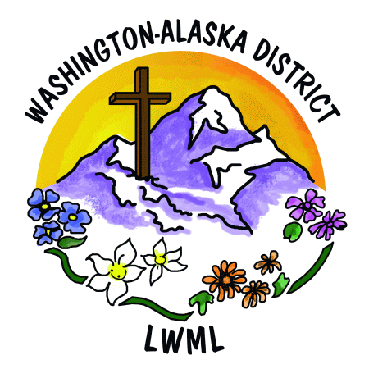**Lutheran Women’s Missionary League**

**Washington-Alaska District**

**MISSION GRANT PROPOSAL FORM**

**DEADLINE: October 31, 2025 SEND TO:** Solveig Schick

Vice President of Gospel Outreach

324 Merrill Way

Port Angeles, WA 98362

solveig.schick@gmail.com

**MISSION GRANT PROPOSALS MUST MEET ALL OF THE FOLLOWING CRITERIA:**

A. The grant is mission-focused and will extend the Gospel and ministry of the Word.

B. Compatible with the plans and projections of the LCMS.

C. Current and ready for implementation within the two years 2026-2028.

D. Well documented with answers to **all** of the questions on the form.

E. Continued maintenance of the mission must be assured.

**NAME OF PROPOSED MISSION:** __________________________________________________________

**LOCATION OF PROPOSED MISSION:** _______________________________________________________

**AMOUNT REQUESTED:**  $ _______________ [Minimum] $ _____________ [Maximum]

**LWML WA-AK DISTRICT SPONSOR:** Member _____ Society _____ Zone _____

*If you do not have an LWML contact within the WA-AK District, please contact Solveig Schick for instructions.

**LWML Contact Person:** _____________________________________________________________

_____________________________________________________________

_____________________________________________________________

Phone: ___________________ Email: ______________________________

**Proposed Mission Contact Person:** ________________________________________________________

_____________________________________________________________

_____________________________________________________________

Organization: _____________________________________________________________

Phone: ___________________ Email: ______________________________

**Funds to be sent to:** _____________________________________________________________

_____________________________________________________________

_____________________________________________________________

Phone: ___________________ Email: ______________________________

The MISSION GRANT proposal **must** contain the following:

1. This fully completed Mission Grant Proposal Form with accompanying information as requested.
2. A resolution to appear before the convention (see sample resolution attached on page 3).
3. Any additional information felt to be necessary.
4. Photographs of the proposed mission and other images, such as a logo, sent on a CD to the address above or electronically to *solveig.schick@gmail.com*. Images will be transferred to a PowerPoint or DVD and shown at the convention during the mission grant presentation, preceding the vote.

**Paper photographs and brochures cannot be used.**

**MISSION GRANT PROPOSAL INFORMATION**

**SUBMIT RESPONSES TO THE FOLLOWING ITEMS IN A SEPARATE TYPED DOCUMENT.**

1. Mission goal statement.

[This may address questions such as: What is the mission emphasis of the grant? How will it spread the Gospel of Jesus Christ or further ministry of the Word of God?]

1. Purpose(s) for which funds will be used.

[This may answer questions such as: Who will be impacted, what is the purpose, where is it located, why is it needed, and how will mission grant funds assist?]

1. (Optional) Specific needs not addressed in item 2.
2. Who is the governing body to whom the organization regularly reports?

[If there is a connection to an LCMS Office of Missions, an RSO, an LCMS congregation or district, or an LCMS partner church, please include that information.]

1. Who is responsible for implementing this proposed mission?
2. Who is responsible for administration of funds for this proposed mission grant?

Questions 7-11 should be answered by someone who will be directly involved in the proposed mission.

1. Are there similar existing programs in the proposed mission’s geographic area?
2. Total amount and source of remaining funds for this proposed mission if funding is only partial for the need.
3. What, if any, alternative funding is available?
4. How will this mission be sustained after the grant monies are used?
5. Financial statement or budget for the proposed mission. This may include: cost of land, facilities, construction, equipment, salaries, scholarships, etc.
6. (Optional) The names and comments of persons having special knowledge of the ministry.
7. (Optional) Additional reasons this proposed mission is important.

If pertinent information is available after the proposal is submitted, also forward it to the address below.

***Return a copy of the Mission Grant Proposal by October 31, 2025 to:***

Solveig Schick

Vice President of Gospel Outreach

324 Merrill Way

Port Angeles, WA 98362

solveig.schick@gmail.com

**NOTE:** The LWML Washington-Alaska District Mission Grants Committee will submit the mission grant proposal to the following for approval:

* The LCMS Northwest District President.
* The national or partner church that the Mission Grant Proposal is involved with.

**NOTE:** These grants are funded through the collection of Mites over the 2026-2028 biennium by LWML Member Groups and LCMS congregations within the LWML Washington-Alaska District. *Sample Resolution:*

**Resolution for Mission Grant Proposal**

(A short project description can go here, or one will be developed by the Mission Grant Committee. Generally, these are two or three sentences that offer a concise description of the mission grant and its goals.)

**WHEREAS** Christ in His Holy Word has declared that visiting the sick and confined is pleasing in His sight (Matthew 25:36, Cf. Matthew 25:31-46); **AND**

**WHEREAS** the number of care center residents is growing quickly as our population ages, and music in the form of Christian hymns and spiritual songs ministers even to those who have dementia; **AND**

**WHEREAS** equipping our volunteers with Biblically-solid resources and useful tools such as the *SonShine* large-print song books, *SonShine* Piano and Leader Book, presentation guides with devotions for older adults, CD’s that accompany the song-books for easy sing-along, and a CD player capable of being used in a larger room with hearing impaired will facilitate expansion of our care center outreach; **AND**

**WHEREAS** Lutheran Ministry Services Northwest wishes to provide materials to equip 10 additional care center ministry teams to bring our Christ-centered nursing home ministry (song services and individual visitation by request) to a total of 20 different locations; **THEREFORE BE IT**

**RESOLVED** that the Lutheran Women’s Missionary League Washington-Alaska District, assembled in convention in Spokane on July 10-12, 2026, adopt as a mission grant for the 2026-2028 biennium the amount of $3,500.00 to enable the equipping of care center ministry teams with needed tools and materials.