

LCMS Alliance Missionaries

Walking Together in the Mission Field

$1,500

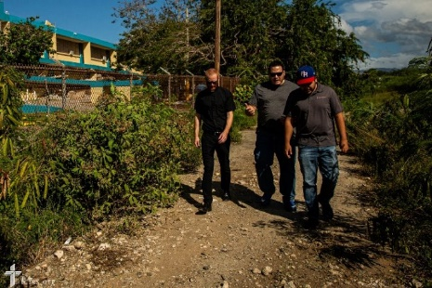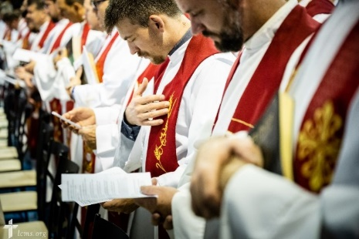

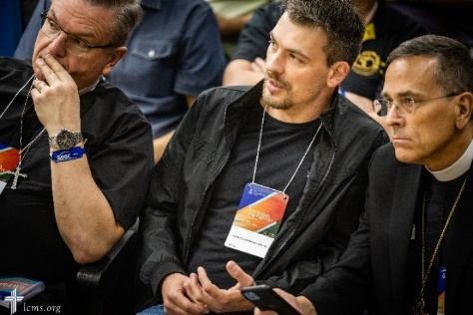

 Alliance Missionaries are pastors supported by the budget of the LCMS. These men are either members of partner churches of the LCMS or men from countries in which mission work is beginning without a parent church body. Alliance Missionaries currently have such pastors in the Dominican Republic, Jamaica, Peru, Panama, Guatemala, Ethiopia, Uganda, Uruguay, South Africa, and undisclosed parts of Eurasia and Asia.

Our grant helps fund the program “Walking Together in the Mission Field” from the LCMS Office of International Mission in support of Alliance Missionaries working alongside and together with LCMS missionaries, complementing and strengthening each other as they spread the Gospel and show mercy to hurting people.

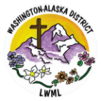

2024-2026 Biennium – LWML Washington-Alaska District